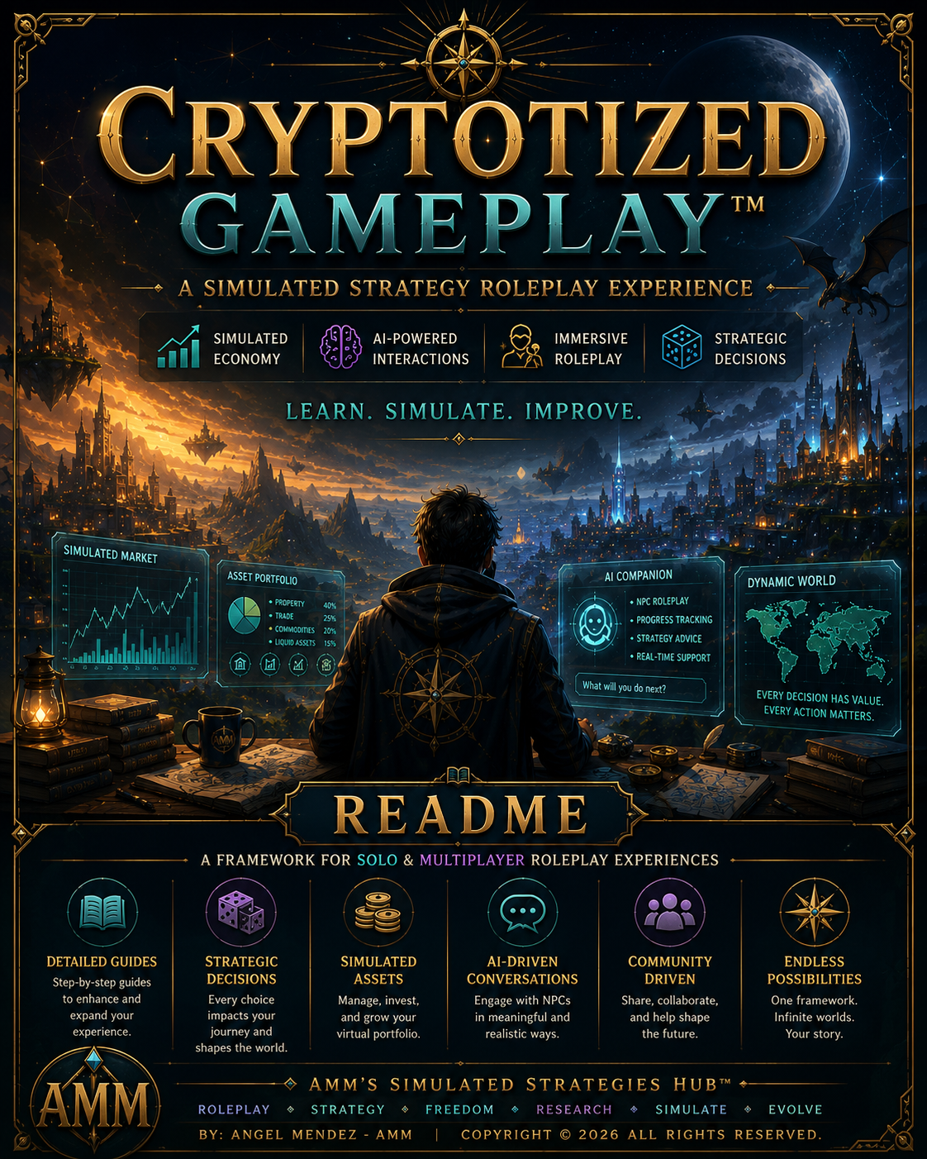

What is….

Cryptotized Gameplay™

As a seasoned gamer born in the 90s, most of us grew up with 3D video games being the new ‘thing’ in our generation. Our games had very little capabilities compared to the successors that came afterward. Some of these major hurdles are a dynamic economic system and a way to have realistic conversations with NPCs. For decades many video games in general, even as modern as Red Dead Redemption 2, lack the ability to show any change in the world beyond physics….

So…. What is Cryptotized Gameplay?

It's a roleplaying strategy I've developed and tested throughout the years in various video game titles, just like the one you're about to try for yourself right now. I utilize many methods and strategies for example….

- Paper Trading Apps (CoinMarketCap/Tradingview)

I'm able to simulate a dynamic economic system that fluctuates in value using real world markets in a virtual (fictitious) environment.

- Ai Chatbots (Chatgpt/Grok/Gemini)

Ai helps users manage their entire roleplaying experience so they can follow along in the actual video game. This includes….

- Roleplaying as NPCs to engage in realistic conversations.

- Keep track of inventory, your progress and other important information as you play along.

- Lastly, users can ask Ai for help with a guide or any details about a game they're playing.

Each game is unique so that means that every guide is tailored to work for that specific game. You can use what you've learned from my guides and start creating your own variations.

Sharing back to the community is important to all roleplayers. It allows us to learn from each other and grow.

Here's how it works, this folder has the following contents for you to view….

- Terms of Use (IMPORTANT!!!)

Before you do anything read this for legalities!

- Community Contributions Guidelines

Want to contribute your own ideas and share them with the community? Read this guide to learn more.

- Cryptotized Gameplay Official Template Guide

An easy to use template that can be used to help you organize your ideas when you are drafting your own roleplaying guides.

- WW Guide Cryptotized Gameplay Beta V 1.0 (The Main Guide)

The main guide explains in full detail on how to get started.

- 7 x WW Cryptotized Gameplay Transcripts (Your References)

Seven screenshots of my conversation with a Chatbot so you can have them as examples.

- 2 x Ai generated cover images
(For Eye Candy)

A copy of AI generated images used in the guides found in this folder for you to marvel.

- Support AMM's Simulated Strategies Hub™

If you've enjoyed your time here and have truly found value in what our community has to offer, there are many ways to support us and this document will show you how.

After going through all the contents in this folder you should have the confidence to get started with your roleplay. If you see any mistakes, have any questions or would like to share any feedback please let me know.

Email: contact@ammstrategieshub.com

# Find me on your favorite platforms #

GitHub: https://github.com/AMMs-Simulated-Strategies-Hub

X-Twitter:
https://x.com/AMMsSimStrategy

Instagram:
https://www.instagram.com/ammssimulatedstrategieshub?igsh=MXEyYmhyZnpxYzRlZg==

The End

In the future, I hope my website and community will become the next GitHub for roleplaying research and development.

Thank you for participating, please feel free to leave feedback on my platforms!

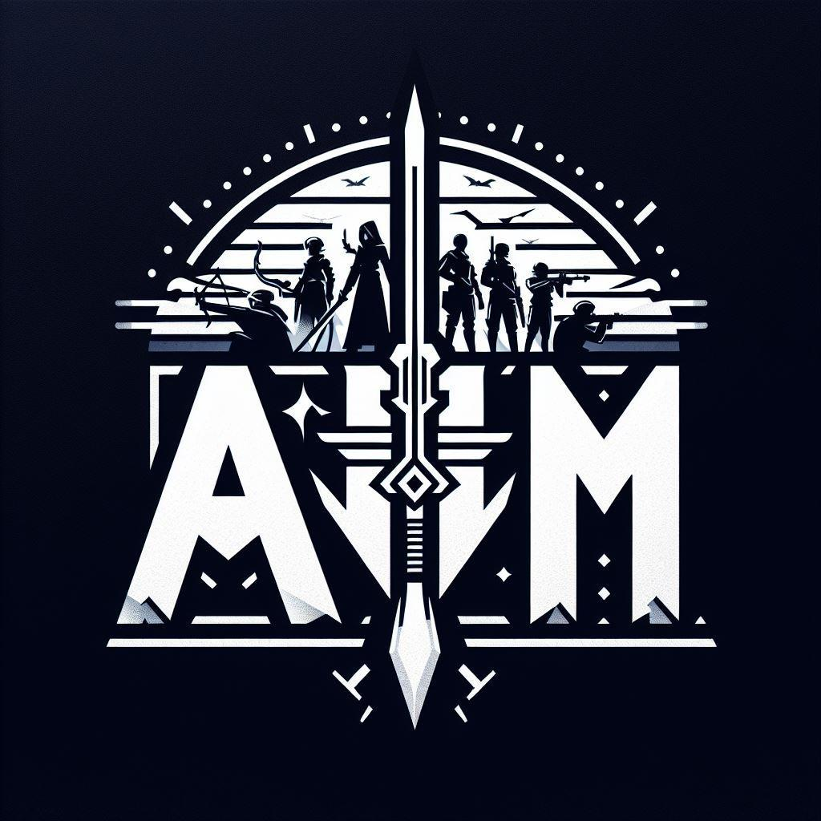

AMM's Simulated Strategies Hub™
Copyright © 2026 Angel Mendez. All Rights Reserved.

